**Motivation:**

Since in every engineering aspect’s we use scientific calculator. We thought of making a calculator using LCD display. Since scientific calculators are expensive in order to make it cost effective we thought of making a calculator using a LCD display and LPC2148 microcontroller from which we can a implement a scientific calculator so that it is cost effective.

**Theory:**

The theory procedure for “Basic calculator” in LPC2148 is as follows:

1. Connect the LCD display to the LPC2148 microcontroller. This is the very first step that typically involve connecting the LCD's data pins (DB0-DB7) to the microcontroller's GPIO (general-purpose input/output) pins, and its control pins (RS, RW, and E) to the microcontroller's digital output pins.

2. Write the program on controlling of the LCD display. This program is used to initialize the LCD display and set it into 8-bit mode for representation. It is also need to implement the functions to write characters and strings to the display, as well as set the cursor position for displaying input and output of the calculator.

3. Now we have to write a program to implement the calculator. This would involve defining the functions for each of the calculator's operations such as addition, subtraction, multiplication, division and using these functions we will have to perform the desired operation when the user inputs the appropriate numbers and operator.

4. In the next step in the microcontroller's input pins we have to read the user's input when presses. This is done by using a loop that checks the state of the input pins at regular intervals of time.

5. Next the microcontroller's output pins is used to control the calculator's display. This would involve updating the LCD display to show the current numbers being input by the user, as well as the result of the calculation when the user presses the "equal" button and the working of operation functioning is to be done.

6. At the end we have to produce the output and print the output in LCD display with users input data.

**Design:** 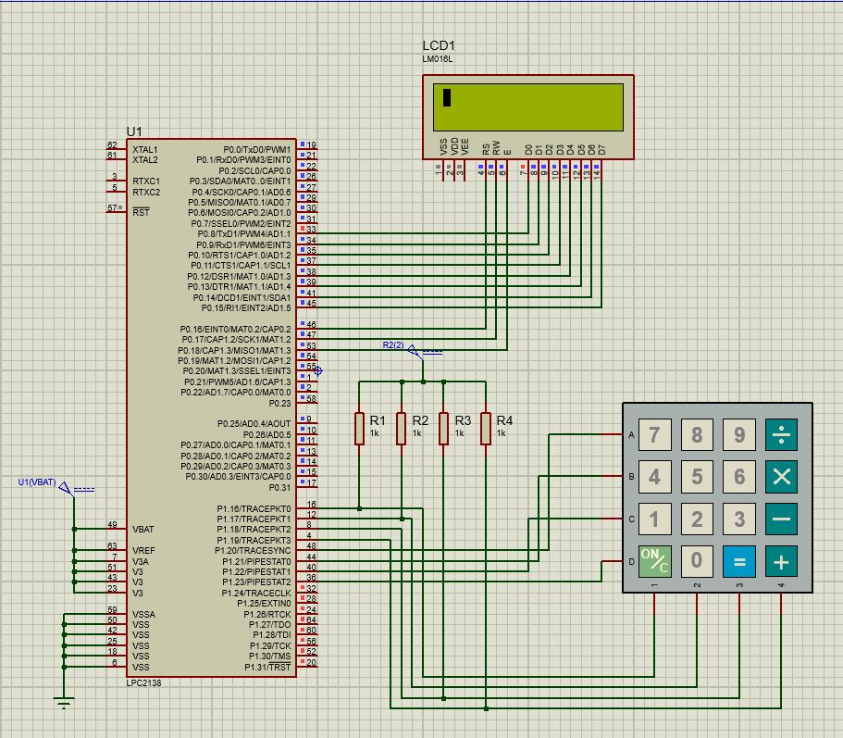

**Code:**

#include <lpc21xx.h>

#include <stdio.h>

#include <stdlib.h>

#define LCD (0xff<<8)

#define RS (1<<16)

#define RW (1<<17)

#define EN (1<<18)

#define col1 (1<<16)

#define col2 (1<<17)

#define col3 (1<<18)

#define col4 (1<<19)

#define row1 (1<<20)

#define row2 (1<<21)

#define row3 (1<<22)

#define row4 (1<<23)

void delay(unsigned int time); // variable delay function

void lcd_ini(void);

void lcd_print(char *str);

void lcd_cmd(unsigned char command);

void lcd_dat(unsigned int data);

unsigned char keypad (void);

void keypad_delay(void);

unsigned int datas(void);

int main (void)

{

PINSEL0 = 0x00000000;

IODIR0 = 0Xffffffff;

PINSEL1 = 0x00000000;

IODIR1 = 0x00f00000;

lcd_ini();

lcd_cmd(0xc0);

while(1)

{

lcd_dat(datas());

keypad_delay();

}

return 0;

}

void keypad_delay(void)

{

unsigned int t1,t2;

for(t1=0;t1<300;t1++)

for(t2=0;t2<1275;t2++);

}

unsigned char keypad (void)

{

unsigned int data;

IOCLR1|=(row1|row2|row3|row4|col1|col2|col3|col4);

while(1)

{

IOCLR1|=row1;

IOSET1|=(row2|row3|row4); // first column = 0

if((IOPIN1&col1)==0)

{

data=7;

keypad_delay();

return data;

}

else if((IOPIN1&col2)==0)

{

data=8;

keypad_delay();

return data;

}

else if((IOPIN1&col3)==0)

{

data=9;

keypad_delay();

return data;

}

else if((IOPIN1&col4)==0)

{

data=55; //"div"

keypad_delay();

return data;

}

IOCLR1|=row2;

IOSET1|=(row1|row3|row4); //second column = 0

if((IOPIN1&col1)==0)

{

data=4;

keypad_delay();

return data;

}

else if((IOPIN1&col2)==0)

{

data=5;

keypad_delay();

return data;

}

else if((IOPIN1&col3)==0)

{

data=6;

keypad_delay();

return data;

}

else if((IOPIN1&col4)==0)

{

data=66; //"mul"

keypad_delay();

return data;

}

IOCLR1|=row3;

IOSET1|=(row1|row2|row4); //third column = 0

if((IOPIN1&col1)==0)

{

data=1;

keypad_delay();

return data;

}

else if((IOPIN1&col2)==0)

{

data=2;

keypad_delay();

return data;

}

else if((IOPIN1&col3)==0)

{

data=3;

keypad_delay();

return data;

}

else if((IOPIN1&col4)==0)

{

data=77; //"sub"

keypad_delay();

return data;

}

IOCLR1|=row4;

IOSET1|=(row1|row2|row3); //forth column = 0

if((IOPIN1&col1)==0)

{

lcd_cmd(0x01);

keypad_delay();

}

else if((IOPIN1&col2)==0)

{

data=0;

keypad_delay();

return data;

}

else if((IOPIN1&col3)==0)

{

data=99; //"equal to"

keypad_delay();

return data;

}

else if((IOPIN1&col4)==0)

{

data=88; //"add"

keypad_delay();

return data;

}

}

}

void lcd_cmd(unsigned char command)

{

IO0CLR|=(RS|RW|EN|LCD);

IO0SET|=(command<<8);

IO0CLR|=RS;

IO0CLR|=RW;

IO0SET|=EN;

delay(2);

IO0CLR|=EN;

delay(3);

}

void lcd_dat(unsigned int data)

{

IO0CLR|=(RS|RW|EN|LCD);

IO0SET|=(data<<8);

IO0SET|=RS;

IO0CLR|=RW;

IO0SET|=EN;

delay(2);

IO0CLR|=EN;

delay(3);

}

void lcd_print(char *str)

{

while(*str!='\0')

{

lcd_dat(*str);

str++;

}

}

void lcd_ini(void)

{

delay(5);

lcd_cmd(0X38);

lcd_cmd(0X0f);

lcd_cmd(0X06);

lcd_cmd(0X01);

delay(5);

lcd_cmd(0X80);

}

void delay(unsigned int time) // variable delay function

{

unsigned int t1,t2;

for(t1=0;t1<time;t1++)

for(t2=0;t2<1275;t2++);

}

unsigned int datas(void)

{

unsigned int num1,num2,op,op2,result,a,b;

char str1[10];

num1=keypad();

sprintf(str1, "%d", num1);

lcd_print(str1);

a=num1;

while (1){

num1=keypad();

if (num1 == 55){

op=55;

lcd_print("/");

break;}

else if (num1 == 66){

op=66;

lcd_print("*");

break;}

else if (num1 == 77){

op=77;

lcd_print("-");

break;}

else if (num1 == 88){

op=88;

lcd_print("+");

break;}

else{

sprintf(str1, "%d", num1);

lcd_print(str1);

a = 10 * a + num1;

}

}

num2=keypad();

sprintf(str1, "%d", num2);

lcd_print(str1);

b=num2;

while (1){

num2=keypad();

if (num2 == 99)

{

op2=99;

lcd_print("=");

break;

}

else{

b = 10 * b + num2;

sprintf(str1, "%d", num2);

lcd_print(str1);

}

}

if (op == 55){

result = a / b;}

else if (op == 66){

result = a * b;}

else if (op == 77){

result = a - b;}

else if (op == 88){

result = a + b;}

else

lcd_print("Enter the correct operation");

sprintf(str1, "%d", result);

if (op2 == 99)

lcd_print(str1);

}

**Results:**

The calculator logic was implemented using conditional statements and arithmetic operations, and the final result was displayed on the LCD display. The calculator was tested by manually entering various mathematical expressions and verifying that the correct results were displayed on the LCD display.

Overall, the basic calculator using the LPC2148 microcontroller was implemented successful and demonstrated the capabilities of the microcontroller and the simplicity of implementing a functional electronic device.

**Inferences:**

In the LPC2148 microcontroller, we have come through the information about the accuracy and speed of the calculator's calculations, the memory usage of the calculator program and time delay. We have collected data on calculator performance like measuring the time it takes for the calculator to perform various calculations, comparing the results of the calculator's calculations to the expected results, and tracking the memory usage of the calculator program are some data interpretations